Customer Engagement & Product Utilization Analytics for Retention Strategy
By Jitin Raju
Abstract
Customer churn is a persistent challenge for banks, often hidden beneath layers of engagement data and product usage metrics. This study applies accessible Python-based analytics to uncover how engagement profiles, product depth, and financial commitment influence retention. Using clear visualizations — such as churn rates across single vs multi-product customers, sticky vs non-sticky profiles, and high-balance disengaged segments — the analysis reveals that engagement and product depth are stronger predictors of loyalty than financial value alone. Premium customers, while financially significant, remain at risk if disengaged, whereas sticky customers demonstrate resilience against churn. The findings support practical retention strategies focused on product bundling, engagement thresholds, and relationship strength indices, offering banks a data-driven yet human-centered approach to reducing churn.
- Introduction
Banks often collect large amounts of customer data, but struggle to translate it into actionable retention strategies. This study uses Python-based analytics and visualization to explore how engagement, product depth, and financial commitment influence churn. The goal is to highlight practical insights that can guide retention decisions.

1.1 Problem Statement
Despite having data on customer engagement and product usage, banks often lack:
- Quantitative insight into which behaviors drive retention
- Clarity on whether product depth reduces churn
- Evidence on whether high balances alone ensure loyalty

1.2 Project Objectives
- Evaluate the relationship between engagement and churn
- Measure retention impact of product count and product mix
- Identify disengaged yet high-value customers

1.3 Secondary Objectives
- Support engagement-driven retention strategies
- Improve product bundling decisions
- Reduce silent churn among premium customers

1.4 Dataset Description
Column | Description
CustomerId | Unique customer identifier
Surname | Customer surname
CreditScore | Customer creditworthiness
Geography | France, Spain, Germany
Gender | Male / Female
Age | Customer age
Tenure | Years with the bank
Balance | Account balance
NumOfProducts | Number of bank products
HasCrCard | Credit card ownership
IsActiveMember | Activity indicator
EstimatedSalary | Estimated annual salary
Exited | Churn indicator (target)

- Methodology
The analysis was carried out in a Jupyter Notebook environment, which allowed for an iterative workflow: running code cells, checking outputs, and refining visualizations step by step. This setup made it easier to validate the dataset and immediately see the impact of each transformation or chart.
The dataset was first ingested and validated using Python libraries such as pandas, numpy, and seaborn. Checks for missing values, duplicates, and consistency in binary variables ensured that the data was reliable before moving into deeper analysis. For example, we confirmed that churn labels (Exited) were consistent and that engagement indicators like IsActiveMember and HasCrCard contained only valid values.
Engagement profiles were then classified into categories based on combinations of activity status, product depth, and balance levels. This classification was coded directly in the notebook, making it easy to adjust thresholds and immediately visualize the impact.
To explore churn, the following dimensions were analyzed:
- Product depth (number of products held): Customers with more products tend to be more “locked in” to the bank’s ecosystem, so we measured whether holding multiple products reduced churn compared to single-product customers.
- Activity status (active vs inactive members): Engagement is often reflected in whether customers actively use their accounts. We compared churn rates between active and inactive members to see how behavior drives loyalty.
- Balance thresholds (premium vs standard customers): High balances are often assumed to signal loyalty, but we tested whether premium customers (balances ≥100,000) were actually less likely to churn.
- Credit card ownership and relationship strength tiers: Credit card holders often have deeper ties to the bank. We also created a composite measure of relationship strength (strong, moderate, weak) based on engagement and product depth, to see how these tiers influence churn.
Visualizations were generated inline in the notebook, using Seaborn and Matplotlib. Each chart was designed to be stakeholder-friendly: churn rates were displayed as whole-number percentages, labels were added above bars for clarity, and redundant legends were removed to avoid clutter. Figures were saved directly from the notebook to ensure reproducibility and easy integration into the research report.
- Results (Exploratory Data Analysis)
3.1 Product Depth vs Churn
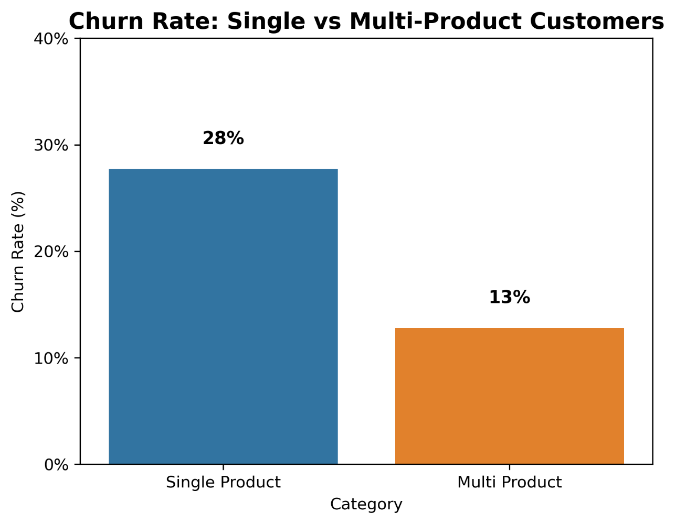
Figure: Churn Rate – Single vs Multi-Product Customers The chart shows churn at 28% for single-product holders compared to 13% for multi-product holders. This confirms that product bundling reduces churn, as customers with multiple products are more “locked in” to the bank’s ecosystem.
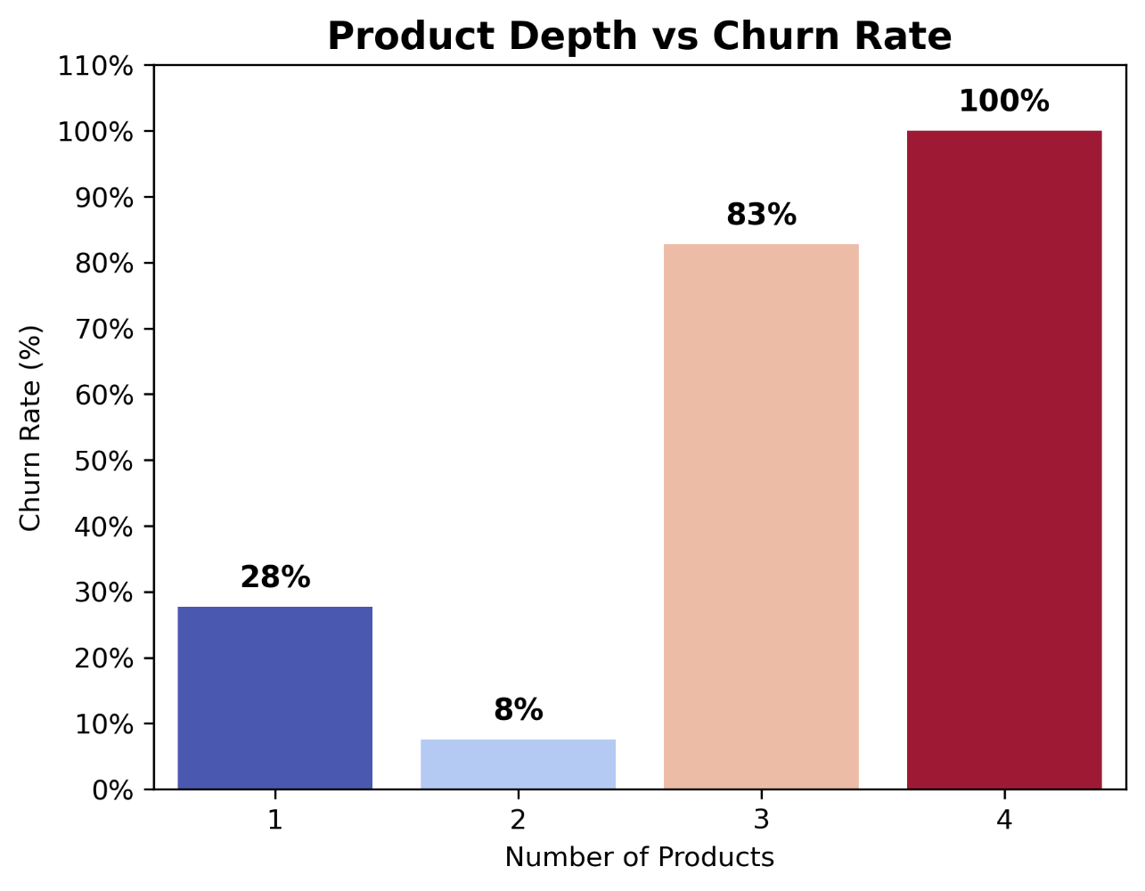
Figure: Product Depth vs Churn Rate The extended view shows churn dropping to 8% for customers with 2 products, but rising sharply to 83% for 3 products and 100% for 4 products.
Relative Context: While bundling clearly helps at the 2-product level, the spike at 3+ products suggests diminishing returns or possibly data anomalies (e.g., very few customers in those categories). In practice, banks should encourage customers to adopt at least two products, but investigate why churn rises among those with 3 or more.

  - Engagement Profiles
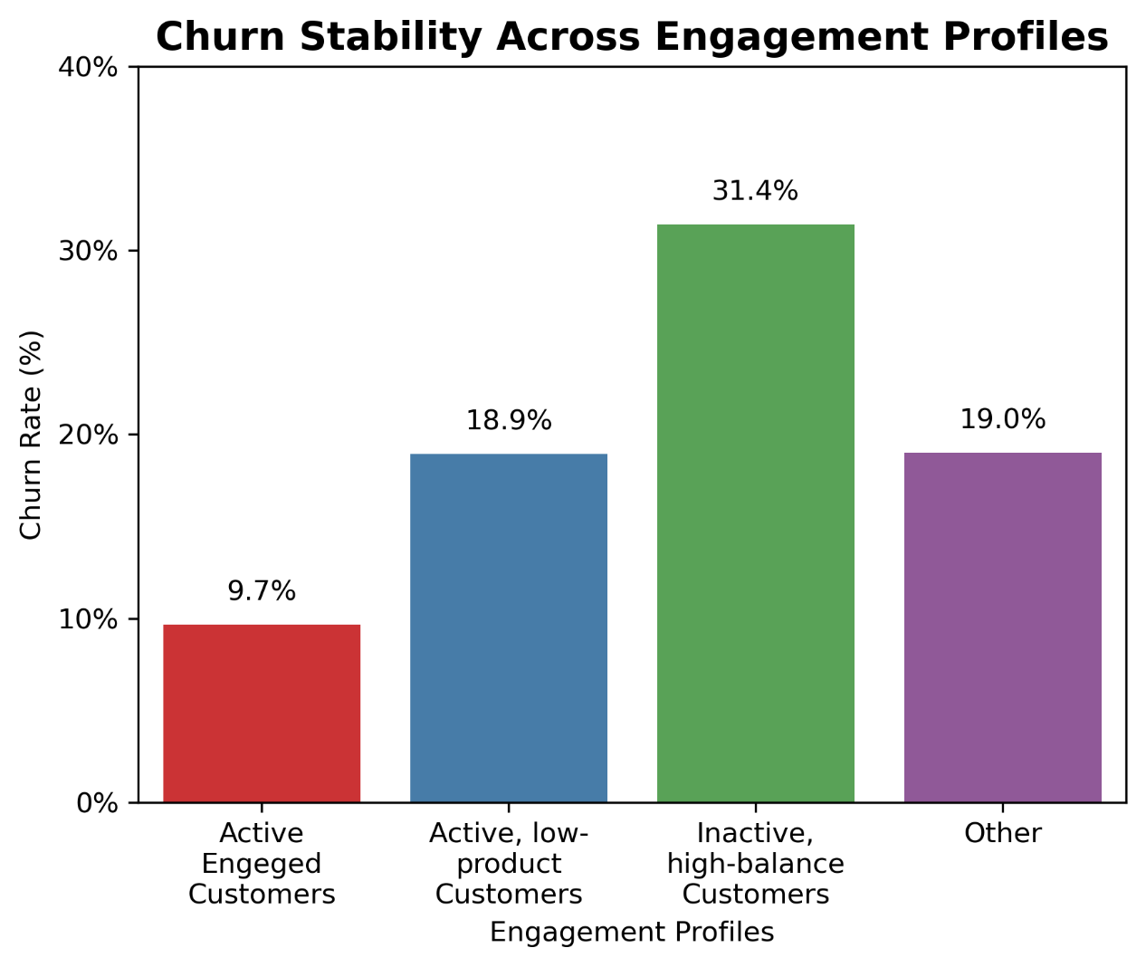
Figure: Churn Stability Across Engagement Profiles Active engaged customers churned at 9.7%, while inactive high-balance customers churned at 31.4%. Active low-product customers churned at 18.9%, and “Other” profiles at 19%.
Relative Context: This highlights that engagement is the strongest predictor of loyalty. Even wealthy customers churn if disengaged, while active customers — even with fewer products — remain more stable. Banks should prioritize engagement campaigns over purely financial segmentation.

  - At-Risk Premium Customers
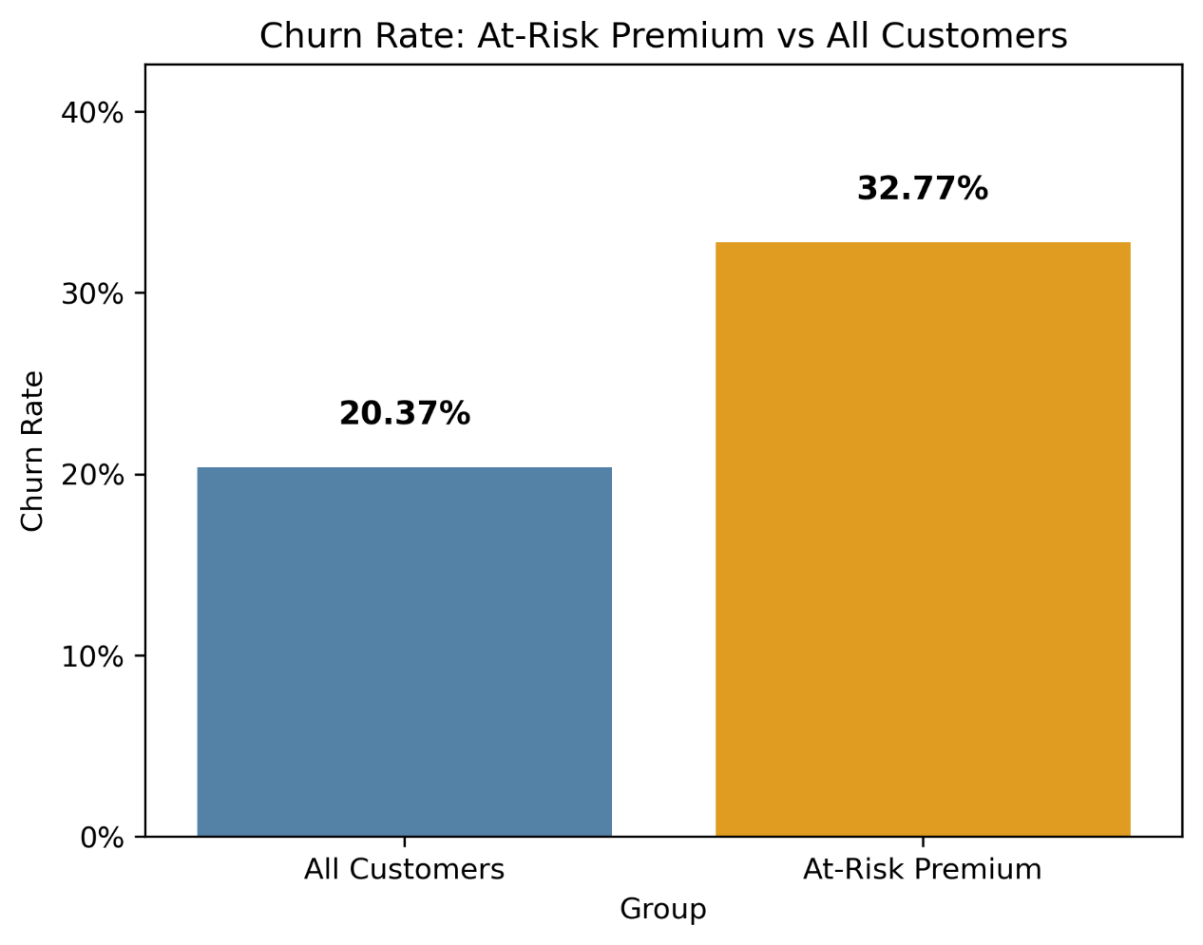
Figure: Churn Rate – At-Risk Premium vs All Customers All customers churned at 20.4%, while at-risk premium customers churned at 32.8%.
Relative Context: This group is financially significant but behaviorally disengaged. Losing them has disproportionate impact, so targeted retention strategies (personalized outreach, premium services) are essential.
  - Sticky vs Non-Sticky Profiles
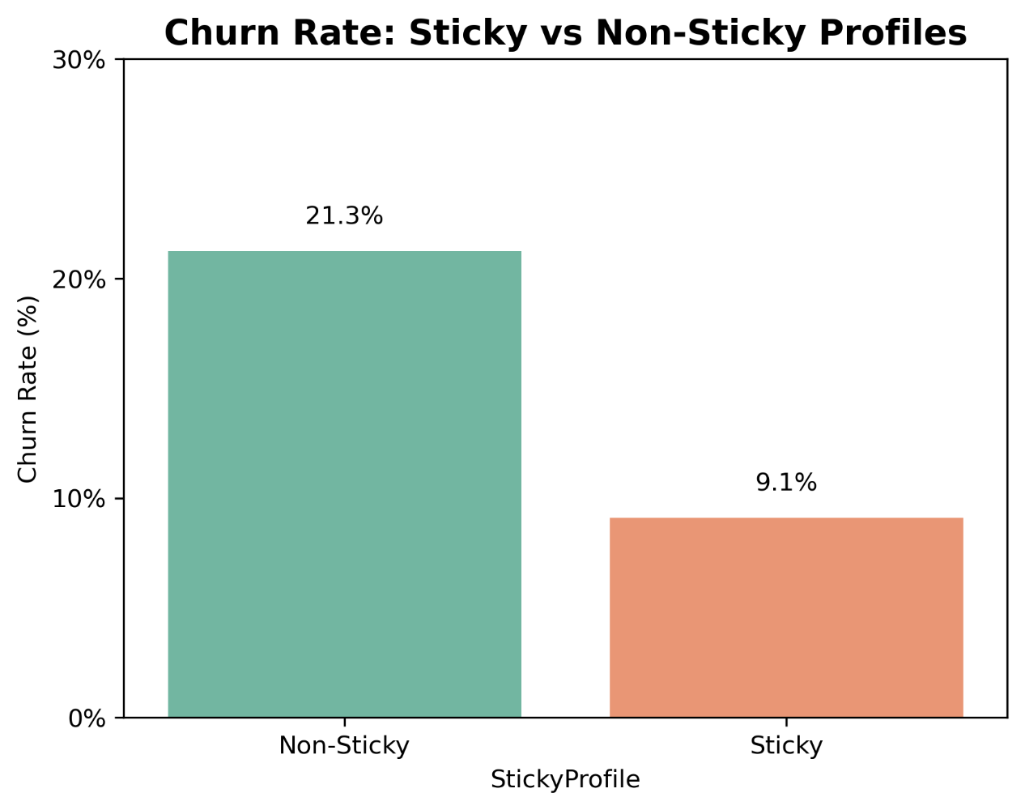
Figure: Churn Rate – Sticky vs Non-Sticky Profiles Sticky customers churned at 9.1%, while non-sticky profiles churned at 21.3%.
Relative Context: Sticky customers represent the ideal retention profile — engaged, multi-product, financially stable, and longer-tenured. Identifying and nurturing these profiles can help banks build a loyal base, while non-sticky customers highlight where interventions are most needed.

  - Engagement Thresholds
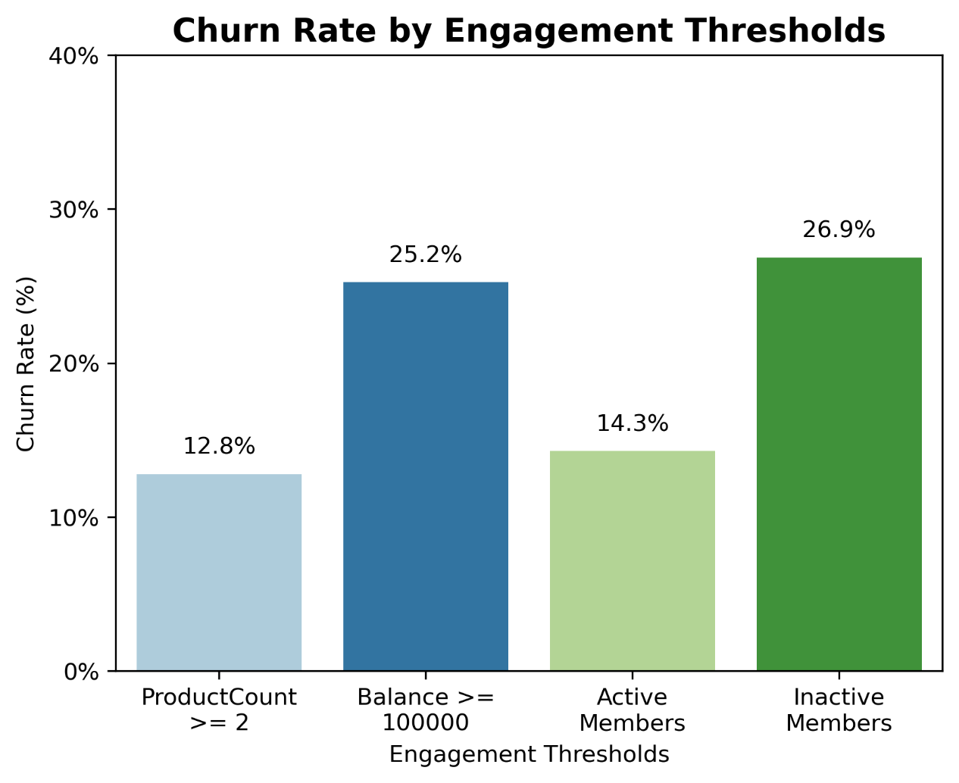
Figure: Churn Rate by Engagement Thresholds
- ProductCount ≥ 2 → 12.8% churn
- Balance ≥ 100,000 → 25.2% churn
- Active Members → 14.3% churn
- Inactive Members → 26.9% churn
Relative Context: These thresholds act as practical benchmarks. Customers with ≥2 products or active status are relatively safe, while inactive or high-balance customers are at risk. Banks can use these thresholds to flag customers for proactive engagement before churn becomes inevitable.
  - Visualization Tools
- Matplotlib: Used for pie charts and static plots.
- Seaborn: Used for enhanced bar charts with color palettes and gridlines, improving interpretability.
All figures were saved as PNGs for integration into the research paper.
- My Analysis
During this project execution, I found out that customer retention is shaped more by engagement and relationship strength than by financial value alone. The figures and charts consistently showed that:
- Product depth matters: Customers holding multiple products churned far less than single-product holders. Bundling creates stickiness and makes customers more invested in the bank’s ecosystem.
- Engagement outweighs wealth: Active customers had churn rates below 10%, while inactive high-balance customers churned above 30%. This proved that disengagement can override even high account balances.
- Premium customers are at risk: Inactive customers with balances above 100,000 churned at nearly one-third, making them a priority for targeted retention campaigns.
- Sticky profiles are resilient: Customers who were active, multi-product, financially stable, and longer-tenured churned at less than half the rate of non-sticky profiles.
- Thresholds provide benchmarks: Holding at least two products or being active reduced churn significantly, while inactivity or high balances increased risk.
In simple terms, I discovered that loyalty is built through active engagement and deeper product relationships, not just through financial value. The project highlighted practical strategies — such as product bundling, engagement campaigns, and identifying sticky profiles — that banks can use to strengthen retention in a human-centered way.

- Conclusion
The figures consistently show that engagement and product depth are stronger predictors of retention than financial value alone. Premium customers can still churn if disengaged, while sticky customers remain loyal even with moderate balances.By focusing on engagement tiers, product bundling, and sticky profile definitions, banks can design retention strategies that are both data-driven and human-centered. As Saiprasad Kagne emphasizes, the value lies not in technical complexity but in clarity and accessibility — insights stakeholders can understand and act upon.

- References
- Arefin, S., Parvez, R., Ahmed, T., Jahin, F., Sumaiya, F., & Ahsan, M. (2024). Enhancing Bank Consumer Retention: A Comprehensive Analysis of Churn Prediction Using Machine-Learning and Deep Learning Techniques. Lecture Notes in Networks and Systems, Springer.
- IEEE Xplore (2024). Customer Retention in Banking: Utilizing AI and Machine Learning for Predictive Insights.
- Academia.edu (2024). Bank Customer Churn Analysis Using Machine Learning Frameworks.

